**Mr SGs Volumetric Analysis Notes**

**Introduction to Chemical Analysis**

-Chemical analysis refers to analyses that use a chemical reaction to solve a chemical problem

-A substance with a known composition is reacted with a substance of unknown composition

-The quantity of the substance with a known composition that reacts can be used to calculate the composition of the other substance

-Chemical analysis may involve determining the concentration of a substance in a solution or the percentage composition of impure substances

-Two common methods of chemical analysis are gravimetric analysis and volumetric analysis

**Gravimetric Analysis:** Determining the mass of a substance produced in a chemical reaction and using the mass to solve a chemical problem

(eg measuring the mass of a precipitate formed and using it to calculate the concentration of a solution)

**Volumetric Analysis:** Using the measured volumes of solutions that undergo chemical reactions and using the volume to solve a chemical problem

(eg measuring the volume of acid required to neutralise a base and using the measured volume to calculate the concentration of the base)

-As the majority of acid-base and redox chemistry occurs in solution, volumetric analysis is the most common mode of analysis in these areas

**Calculations involving acids and bases**

-To perform chemical analysis of acids and bases, it is necessary to write equations and perform stoichiometric calculations

-Acids and bases react according to the following general equations:

- acid + metal → salt + hydrogen

- acid + base → salt + water

- acid + metal carbonate/hydrogencarbonate → salt + water + carbon dioxide

- acid + metal sulfide → salt + water + sulfur dioxide

- base + ammonium salt → salt + water + ammonia

-Because chemical analysis (particularly volumetric analysis) involves reacting substances in stoichiometric quantities, the calculations involved do not typically involve limiting reagent calculations

-The flow chart below is a guide to solving the types of stoichiometry problems typically used in chemical analysis

-The pathways in red are most commonly used for volumetric analysis

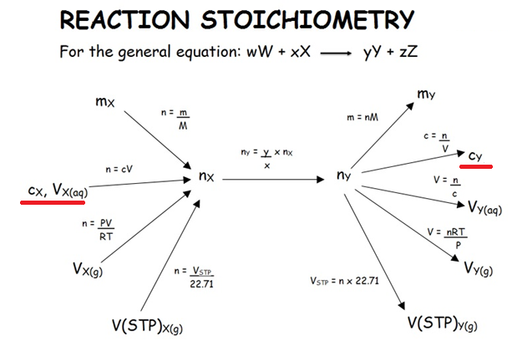

**Volumetric Analysis**

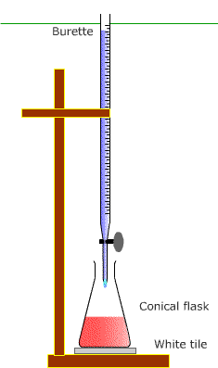

**Principles of volumetric analysis & titrations**

-During volumetric analysis, the concentration of a solution can be calculated based its reaction with a solution of known concentration (standard solution)

-When an appropriate indicator is added to the reaction vessel, a colour change will occur when stoichiometric quantities of reactants have been added

-This procedure is known as a titration (see image)

-The number of moles of the standard solution can be calculated from its concentration and volume

-That can be used to calculate the number of moles and the concentration of the solution of unknown composition

**Types of Standard Solutions**

-A standard solution is a solution of known concentration

-Accurate and precise volumetric analysis relies on the preparation of standard solutions with concentrations that are known with a high degree of precision

-**Primary standards** are those that have a known concentration, as they have been prepared by adding water to a measured mass of the solid standard, containing a known number of moles of the standard

-**Secondary standards** are those that have a known concentration as their concentration has been determined by titrating them against a primary standard

-Many of the substances commonly used in acid: base titrations cannot be used as primary standards, as they have variable or changing compositions

-This is because they are either gain or lose water from the atmosphere (deliquescent/hygroscopic) (Group 1 hydroxides, conc. H2SO4) or are of variable composition (conc. HCl, conc. HNO3)

**Primary Standards**

-To be a good primary standard, the number of moles contained in a given measured mass of a substance must be known with high degree of certainty

Characteristics of a primary standard:

-Can be obtained with a high degree of purity and has a known formula

-Undergoes reactions according to known chemical equations

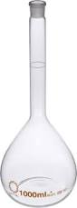

-Must be stable/ must not change composition upon exposure to the atmosphere

-Should have a relatively high formula mass (weighing errors will have less of an impact on the number of moles present)

-Good primary standards for acid/base titrations include anhydrous sodium carbonate (Na2CO3), oxalic acid (H2C2O­4.2H2O) and potassium hydrogenphthalate (KHC8H4O4)

-Primary standard are prepared in volumetric flasks as they have a very accurately known volume

**Preparing a primary standard**

1. Calculate the mass required to provide a given concentration when dissolved in the volume indicated on the volumetric flask
2. Weigh out a mass of the standard close to the calculated mass and record the mass used
3. Quantitatively transfer the solid to the volumetric flask
4. Add a small amount of dH2O and swirl to dissolve the liquid
5. Add more dH2O to make the solution up to the calibrated mark on the flask (so that the bottom of the meniscus is level with the line)
6. Thoroughly shake the solution to ensure it is completely dissolved.

**Preparing a secondary standard**

1. Prepare a solution with the approximate concentration required, from either a concentrated solution or from the solid secondary standard
2. Standardise the solution by determining it’s concentration by titrating it against a primary standard of known concentration

**Volumetric Analysis: Titrations**

-In a titration a known volume of one solution is pipetted into a conical flask, along with an appropriate acid base indicator

-The second solution is added with a burette until the indicator changes colour, indicating that the reaction is complete

-The concentration of the solution of unknown composition can then be calculated based on the concentration of the standard solution and the volumes of the two solutions

-Titrations require the use of specialised equipment to accurately and precisely measure and deliver the volumes solutions being titrated

**Equipment used in volumetric analysis**



**Rinsing Procedures**

-Special rinsing procedures are used during titrations to ensure that the results are accurate

-Equipment is rinsed with either distilled water or the solution they will hold, based on whether they need to contain a solution with a known concentration, or a known number of moles

-Volumetric flasks are rinsed with distilled water. This is to prevent changing the number of moles of the standard that they contain. This allows a solution of known concentration to be prepared by filling the flask up to a measured volume with distilled water

-Pipettes and burettes are rinsed with the solution they will deliver. This is to prevent changing the concentration of the substance they will deliver. The concentration needs to be kept constant, so that the measured volume delivered can be used to calculate the number of moles delivered (n=cV)

-Conical flasks are mixed with distilled water. This is to ensure that the number of moles of reactants is not altered, by ensuring that the only reactants in the flask are those delivered by the pipette and burette

**Performing a titration**

1. A fixed, accurate volume of one of the solutions is added to a conical flask using a pipette. The indicator can also be added at this point.
2. A burette is used to deliver a variable volume of the second solution until the reaction is complete.
3. A rough titration should be performed first to estimate the volume required.
4. The titration should be performed several times by using the burette to add a volume close to that used in the rough titration, then adding the solution dropwise until the reaction is complete.
5. The titration should be repeated to give 2-3 concordant titres (within 0.1 mL) and averaging these to get the final titre used for subsequent calculations.

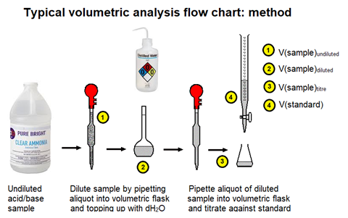

**Determining when a titration is complete**

-Titrations rely on being able to accurately determine when the reactants have completely reacted (at the equivalence point)

**Equivalence point**: The point during a reaction when stoichiometric amounts of reactants have been added

-In acid base titrations, the reaction will be accompanied by a non-linear pH change, with the largest change occurring near the equivalence point



-It is possible to determine when the equivalence point has been reached by using a pH meter to monitor the pH change during the titration

-It is also possible to use a pH indicator to indicate when the reaction is complete

**End point:** The point during a reaction where an indicator changes colour, indicating that the reaction is complete

-In order to accurately measure the amount of reagent required to react completely, it is necessary to choose an appropriate indicator, so that the end point matches the equivalence point

-This is done by choosing an indicator with a pKa close to the pH of the solution at the equivalence point

-The pH at the equivalence point depends on the strength of the acid and base being titrated

|  |  |  |  |
| --- | --- | --- | --- |
| **Acid used** | **Base used** | **pH at equivalence point** | **Suitable indicators** |
| Strong | Strong | ~7 | methyl orange, phenolphthalein |
| Strong | Weak | < 7 | methyl orange |
| Weak | Strong | > 7 | phenolphthalein |
| Weak | Weak | varies, but change is less marked than other titrations | pH meter only |

**Volumetric analysis (calculations)**

-The concentration of the unknown solution can be calculated based on the concentration of the standard solution and the volumes of the two solutions that reacted during the titration.

-The volume and known concentration of the standard can be used to calculated the number of moles of the standard that reacted

n(standard) = cV

-The stoichiometric ratios of the reactants can be used to calculate the number of moles of the sample that reacted with the standard

n(sample) = coeff(sample) x n(standard)

coeff(standard)

-The concentration of the sample can be calculated from the number of moles that reacted

c(sample) = n .

V

-The concentration of the sample can then be used to perform further calculations if required (eg mass, % comp, etc)

-As the sample will often be diluted prior to the titration, it is often necessary to perform a dilution calculation to determine the concentration of the undiluted sample

c(sample)undil = V(sample)dil x c(sample)dil

V(sample)undil

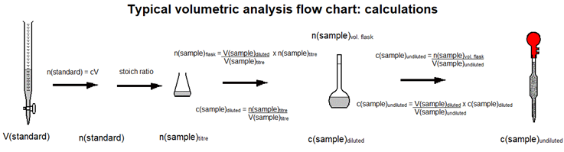

**Back Titrations (eg asprin)**

-Some substances are unsuitable for analysis using conventional titrations, eg asprin is a weak acid that is insoluble in water

-The amount of asprin can be calculated by reacting it with a known volume of a known concentration of excess sodium hydroxide.

-The concentration of the sodium hydroxide present following the reaction can then be quantified by titration with hydrochloric acid

-The amount of asprin present can be calculated from the amount of sodium hydroxide that reacted (eg the discrepancy between the initial and final concentrations of sodium hydroxide)

-This is known as a “back titration”